**FISH 458/558 - Fish Population Dynamics**

**LAB ASSIGNMENT #8 (Yield per recruit and Spawner per recruit models)**

*Complete and return your assignment (via Canvas) in the form of a Word document by the due date (with any answers and figures requested and with the R script copied in).*

*Guidelines:*

* *Include the course, lab number, and date at the top of the document*
* *Number and label the questions and answers clearly! (We should easily be able to find your answers!)*
* *Include all of the requested output (e.g., values, data tables, and plots), not just the code for them. (We will not copy your code into R to see if it works).*
* *Include informative captions for figures and tables. See research articles for examples.*
* *Submit a Word document unless directed otherwise (no r files or pdfs please).*
* *Include all your code used for the problems.*
* *Answer ALL questions using complete sentences that are clear and informative.*

**ALL STUDENTS (458 & 558)**

**Yield-per-recruit (10 pts)**

1. Use the **haddock** data set from the lab exercise. In the lab, we looked at the yield per recruit curves under three scenarios of knife edge selectivity where the age at first capture (tc) was age-1, 3, and 5. Repeat the analysis (using the same data and inputs) but this time include two additional scenarios of tc=age-2 and tc=age-4. Assume that M=0.4, there is no plus group (plus=F), maximum F (maxF) = 2, and F increment (incrF) = 0.01.
   1. Generate a plot with colored lines representing each of the 5 scenarios. (4 pts)
   2. Create a table that identifies the F0.1 reference points for each of the 5 scenarios. Explain what F0.1 is. (3 pts)
   3. A fisheries manager asked you to conduct this analysis to determine what age the haddock fishery should target to have high yields without experiencing growth overfishing. What is your recommendation for a fishing mortality rate (note: use F0.1 and not Fmax) and age at first capture based on these 5 scenarios? Describe why, and include a description of what growth overfishing is. (3 pts)

**Spawner-per-recruit (10 pts)**

1. Continue to use the **haddock** data set. Assume the fishery has knife-edge selectivity with fish becoming vulnerable to the fishery at age 3. Also, assume that 50% of the natural mortality and fishing mortality occur before spawning, and that M=0.4. Other analyses have indicated that the population should be no lower than 40% of its maximum spawning potential (MSP) to keep the stock sustainable. Conduct a spawner per recruit analysis to determine the effect of the current fishing mortality rate for the population, which is estimated to be F=0.55.
   1. Is the current F too high or too low based on the desired objective of achieving 40% MSP? The current F of 0.55 is achieving what percentage of MSP? [HINT: look at the data output from the *sbpr* function]. Include a plot to support your answer. (4 pts)
   2. Assuming no changes are made to the age at first capture, what would be a more appropriate fishing mortality rate (rounded to 2 decimal places) to achieve 40% MSP? In preparing to present this recommended F rate to a lay audience, you choose wisely to express F (an instantaneous rate) as an annual exploitation rate (u) from 0-1. [Assume that the fishery is a Type II, continuous fishery and use the appropriate equation from the lecture notes.] Describe what the exploitation rate means using percentages and compare it to the exploitation rate for the current F (F=0.55). (3 pts)
   3. Describe what **Spawner per recruit**, **40% MSP**, and **recruitment overfishing** mean. (3 pts)
2. How much time did this whole assignment take you? (For undergrads, please distinguish between the time spent on the regular assignment and the extra credit if you attempt it.)

**558 Students (4 pts extra credit for 458):**

**Contour plots (8 pts) – Goal: figure out how to make a graph that we haven’t covered in class.**

1. Your task is to expand on question 1 using the haddock data to create a contour plot that represents how YPR changes as a function of both F (ranging from F=0-1.5) and age at first capture (tc, ranging from 1-10). Your figure should look something like the example given below but have your X-axis be F, and your Y-axis be tc. The colors/contours should denote different YPR values. Include a legend for the different colors. [Hint: there are packages and functions to help you create plots like these. The key will be finding out what to use and how to organize your data. In the past, students have used package **plotly** (function **plot_ly**), package **ggplot2**, and function **contour()** in the base package; they each have pros and cons.]

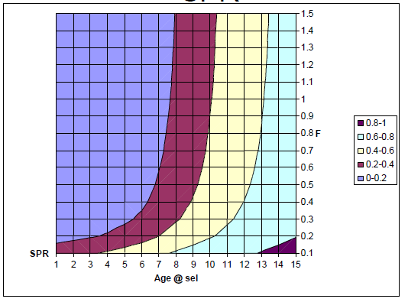

* 1. Create a figure as described, with a caption. Include the code used to create your plot (5 pts)
  2. Use your figure to discuss how YPR changes as a function of F and tc, and how this might impact your management recommendations as discussed in question 1c. (3 pts)

*If using gpt, mention how it worked in your response*